Implementing Dr. NIM – Requirements Engineering

- General introduction:
Dr. Nim is a logic game based on a mechanical computer that can also serve as a good study object in computational or algorithmic thinking courses.
“Dr. Nim is a toy invented by John Thomas Godfrey^{[1]} and manufactured by E.S.R., Inc. in the mid-1960s. It consists of a marble-powered plastic computer capable of playing the game of Nim. The machine selects its moves through the action of the marbles falling through the levers of the machine.” (https://en.wikipedia.org/wiki/Dr._Nim#External_links)
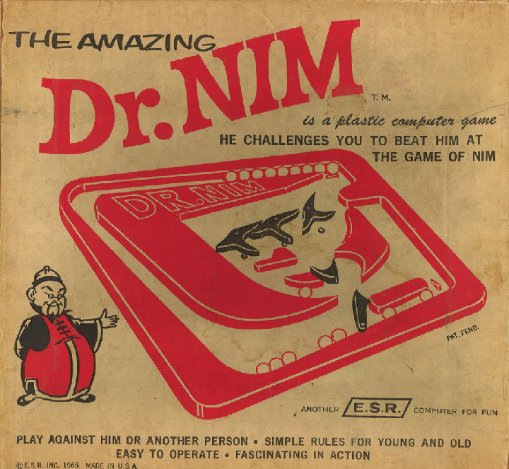
The original manual that was shipped with the physical mid-1960s game is available on the internet and was found by the team while researching existing implementations of the game. (Link to original manual: https://www.kareltherobot.ch/website/amazingdrnim.html)
The Dr. NIM manual goes further than simply explaining the rules by offering an in-depth analysis of the mechanical and logical foundations of the game, including Boolean algebra and flip-flop mechanisms. It covers winning strategies, as well as different starting configurations for slightly different scenarios of beating Dr. NIM.
General rules: The game is played by 2 players, each taking turns removing 1, 2 or 3 marbles from a pile of a given number of marbles. Depending on the variation goal, the one taking the last marble is either the winner or the loser. The design of the toy allows the game to be played by either 2 persons, a person against Dr. NIM or Dr. NIM against himself – this is configured through the turn switch, one of the moving plastic pieces.

- Goal of the project: Implementing Dr. NIM
The game will be implemented as a 2D browser game, focusing on providing an interactive platform for studying the mathematical model and strategic principles of Dr. NIM.
Functional requirements (User experience / Game features):
- The main menu should present the user with instructions and allow him to choose between different starting configurations and different variations of the game.
- The different variations will differ from each other through:
- The number of marbles in the initial pile
- The goal of the game (The one who takes the last marble is the winner / looser)
- Who is playing the game:
- 2 users on the same device / the same user against himself;
- The user against Dr. Nim (2 modes: normal / impossible – The idea is based on the position of the Equalizer piece)
- Dr. NIM against himself (Dr. NIM 1 vs. Dr. NIM 2) – The user is watching as the game is played automatically and can observe the result of such scenario.
- The user will interact through buttons for choosing the variation, while the visual representation of the game (the moving plastic pieces) will be configured automatically in the correct positions so that the rules of the game are followed.
- The design of the game automatically prevents Dr. NIM from cheating (taking more than 3 marbles), but the implementation will also prevent the user from cheating.
Non-functional requirements:
- Intuitive user interface
- All game logic and interactions will run fully client-side in the browser
- Run without errors in modern web browsers
- Scope constraint: Designed for desktop and tablet displays

- Implementing tools and specifications
The team has considered the following tools for implementing Dr. NIM. If required, other tools will be considered and used for the implementation.
Programming languages and frameworks:
- HTML5 + CSS (front end, game visuals, structure of content in browser
- JavaScript (primary programming language for game logic and user interaction)
- JavaScript Frameworks (ex. Phaser.js) will be considered to simplify 2D rendering, animation and the development of the project
Development Environment:
- Visual Studio Code
- GitHub
- Microsoft Azure DevOps

Status update report : 09.10.2025 - 23.10.2025

  - Main focus of the team - Design:
With the main requirements of the project in mind the teams focus laid with the design and aspect of the center-piece of the browser game, the Dr. Nim board itself.
  - Design of the board-game:
After experimenting with multiple tools for modelling the complex shapes of the individual pieces, the team ended up using the free, easy-to-use tool boxy-svg.com for designing the individual parts.
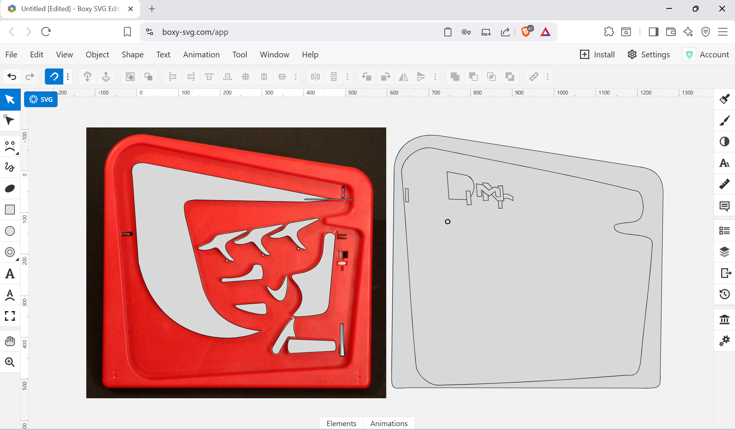

As seen in the picture above, the outline of the individual parts were manually traced and exported as separate scalable vector graphics files (SVGs), from where the paths were extracted and integrated afterward in a structured code block (html + css) for the main SVG of the board game.

Approaching the design of the individual pieces separately allowed the team to capture a very detailed image of the game. Moreover, using a single screenshot of the actual Dr. NIM board allowed the design to be proportionate and to represent truthfully the general image of the iconic game.
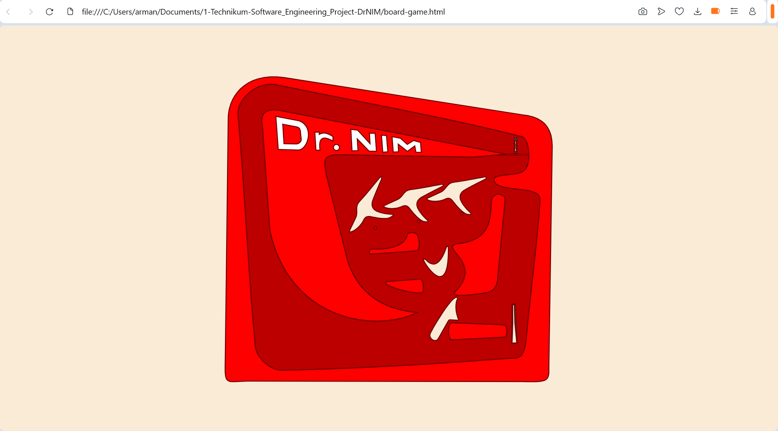
Having worked out the general design of the center-piece of the project, the team started working on the design of the overall browser-page. In the picture below an early prototype of a game-menu can be seen.
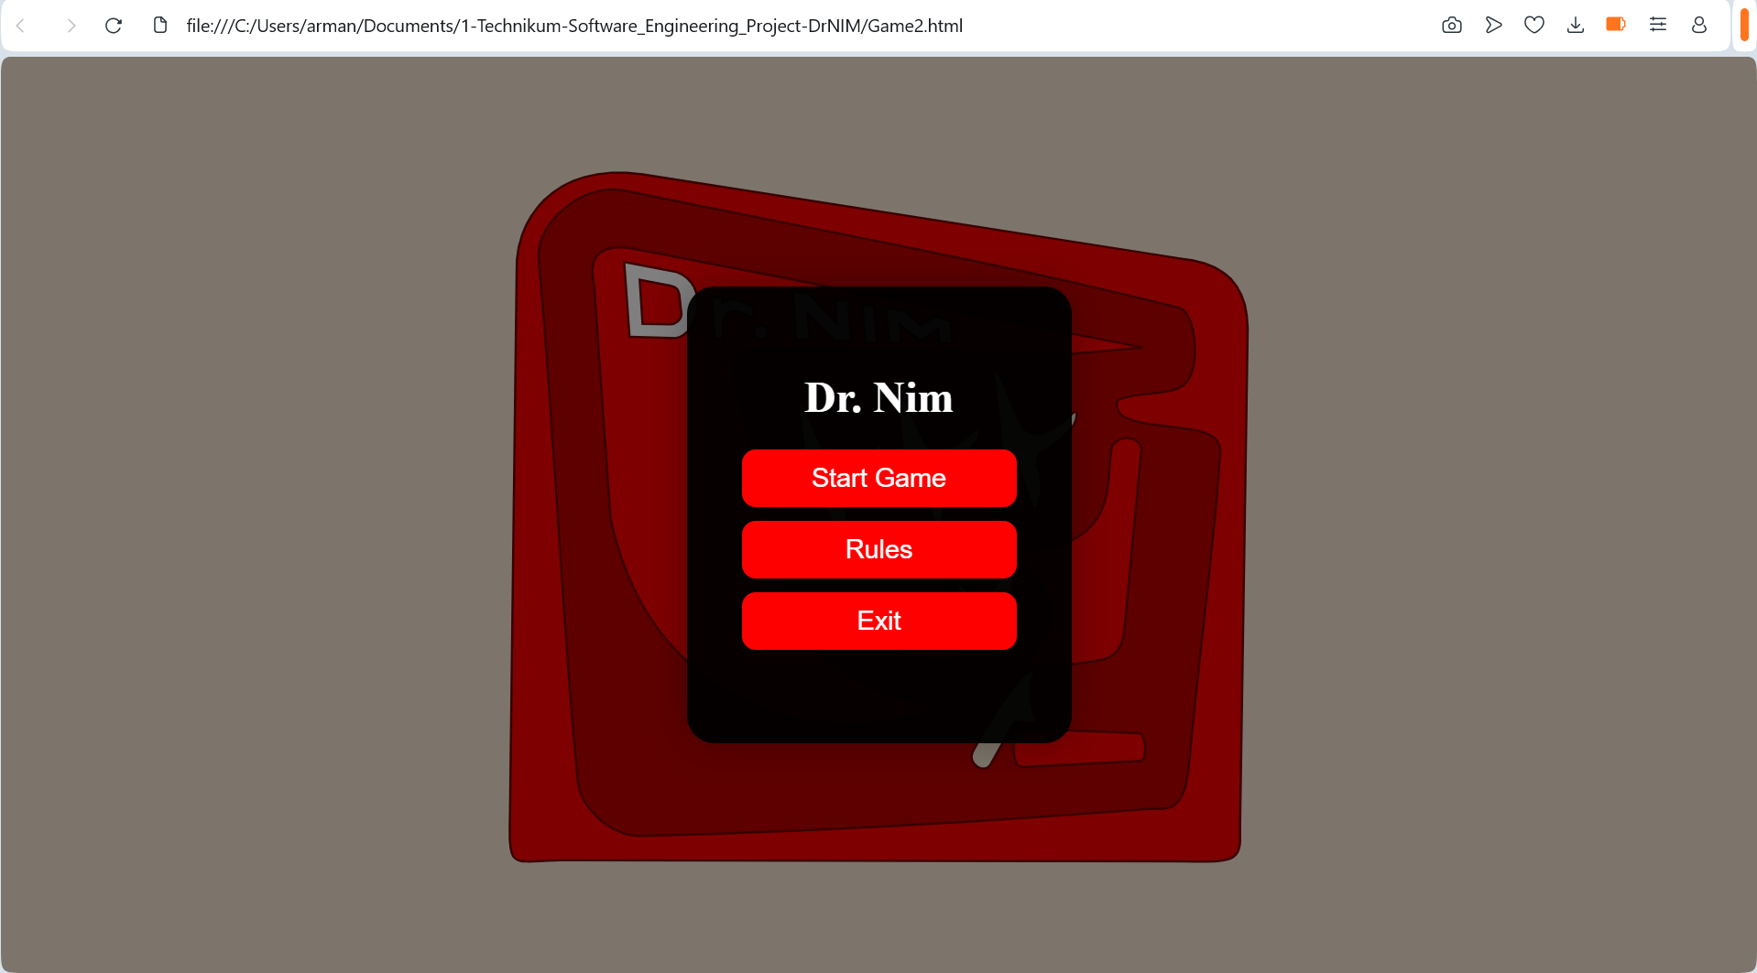

  - Main board-logics (animation of the moving pieces):
Working in parallel with the further design of the overall browser-page, the team has also started working on the functionality of the Dr. NIM game (JavaScript).
The team successfully managed to represent the natural movement of moving pieces:
- The equalizer in the middle and the turner can be clicked to change their position.
- The trigger button in the corner can be clicked aswell as activated by pressing ENTER, simulating the press of the button and the push of the future (to be added) marbles in the top right corner, just as in the real physical game.
- The 3 flip-flop gates / levers currently work as a counter, simulating their natural movement
A copy of the current state of the project will be saved with the todays date for future reference (3 files – 1 HTML, 1 CSS, 1 JavaScript).

  - Next focus of the team until the next status update meeting:
The teams focus will be to continue in parallel the overall design of the browser-page, as well as working further on the functionality of the game, mainly searching for solutions on the animation of the marbles rolling.

